HALOXYFOP-P-METHYL
526

ISO common name Haloxyfop-P-methyl
Chemical name Methyl (R)-2-[4-(3-chloro-5-trifluoromethyl-2-pyridyloxy)phenoxy]propionate (IUPAC); (+)-2-[4-[[3-chloro-5-(trifluoromethyl)-2-pyridinyl]oxy] phenoxy]propanoic acid methyl ester (CA; 72619-32-0)
Empirical formula C₁₆H₁₃ClF₃NO₄
RMM 375.7
b.p. > 280°C
v.p. 2.6 × 10⁻⁵ Pa at 20°C
Solubility In water 9.08 mg/l at 20°C.
In most organic solvents > 1000 g/l at 20°C.
Description Light amber, viscous liquid
Stability Unstable in alkaline conditions
Formulations Emulsifiable Concentrate (EC)
HALOXYFOP-P-METHYL TECHNICAL
526/TC/(M)/-

1 Sampling. Take at least 50 g.

2 Identity tests.
2.1 HPLC. Use the HPLC method below. The retention time of haloxyfop-P-methyl for the sample solution should not deviate by more than 2% from that of the calibration solution.
2.2 UV spectrum. Use the HPLC method 526/TC/(M)/3 and record the spectrum of the haloxyfop-P-methyl peak with a diode array detector. The spectrum obtained from the sample should not differ significantly from that of the standard (Fig. 1).
2.3 IR. Prepare potassium bromide discs from the sample and from pure haloxyfop-P-methyl. Scan the discs from 4000 – 600 cm⁻¹. The spectrum produced from the sample should not differ significantly from that of the standard (Fig. 2).

3 Haloxyfop-P-methyl.

OUTLINE OF METHOD Haloxyfop-P-methyl (R-enantiomer) is separated from the S-enantiomer and other components and is determined by normal phase high performance liquid chromatography on a chiral phase column using UV detection at 280 nm and external standardization.

REAGENTS
Haloxyfop-P-methyl of known purity. Store refrigerated.
Heptane
Propan-2-ol
Methanol
Dilution solvent. Heptane – propan-2-ol, 80 + 20, (v/v)
Mobile phase. Heptane – propan-2-ol – methanol, 85 + 5 + 10, (v/v)
Calibration solution. Prepare calibration solutions in duplicate. Weigh (to the nearest 0.1 mg) about 130 mg (s mg) of haloxyfop-P-methyl directly into a wide mouth bottle (100 ml). Add by pipette dilution solvent (50.0 ml), place the bottle on a mechanical shaker for 5 min and mix.

APPARATUS
Liquid chromatograph equipped with a variable-wavelength UV detector operated at 280 nm.
Liquid chromatographic column, 250 × 4.6 (i.d.) mm, packed with Chiralcel OK with 10 µm particles (Chiral Technologies, Inc., No. 18025), or equivalent.
Integrator or data system
Mechanical shaker

PROCEDURE
(a) Operating conditions (typical)
Column 250 × 4.6 (i.d.) mm, packed with Chiralcel OK with 10 µm particles
Mobile Phase heptane – propan-2-ol – methanol, 85 + 5 + 10 (v/v)
Flow rate 1.8 ml/min
Temperature 25°C
Detector Wavelength 280 nm
Injection Volume 10 µl
Run duration 15 minutes
Retention times haloxyfop-P-methyl: about 4.5 min
S-enantiomer: about 6.0 min

(b) Sample preparation. Weigh (to the nearest 0.1 mg) in duplicate directly into two wide mouth bottles (100 ml) about 130 mg (w mg) of haloxyfop-P-methyl. Add by pipette dilution solvent (50.0 ml), place the bottle on a mechanical shaker for 5 min and mix.
(c) System Equilibration. Pump sufficient eluant through the column to equilibrate the system. Inject 10 µl of calibration solution into the column and adjust the operating conditions to give retention times about 4.5 and 6.0 min for haloxyfop-P-methyl and S-enantiomer respectively. Resolution between the enantiomers should be ≥1.5. Inject 10 µl portions of the calibration solution until the response factors obtained for two consecutive injections differ by less than 1.0%. Then inject 10 µl of a second calibration solution. The response factor for this solution should not deviate by more than 1.0% from that for the first calibration solution, otherwise prepare new calibration solutions.
(d) Determination. Inject in duplicate 10 µl portions of the sample solution bracketing them by injections of the calibration solutions as follows: calibration solution C_{A}, sample solution S_{A}, sample solution S_{A}, calibration solution C_{B}, sample solution S_{B}, sample solution S_{B}, calibration solution C_{A}, and so on. Measure the relevant peak areas.
(e) Calculation. Calculate the mean value of each pair of response factors bracketing the two injections of a sample and use this value for calculating the haloxyfop-P-methyl contents of the bracketed sample injections.
$$f_{i}=\frac{s×P}{H_{s}}$$

$\text{Content of haloxyfop-P-methyl }=\frac{f×H_{w}}{w}$ g/kg

where:
f_{i} = individual response factor
f = mean response factor
H_{s} = peak area of haloxyfop-P-methyl in the calibration solution
H_{w} = peak area of haloxyfop-P-methyl in the sample
s = mass of haloxyfop-P-methyl working standard in the calibration solution (mg)
w = mass of the sample taken (mg)
P = purity of haloxyfop-P-methyl working standard (g/kg)

Repeatability r = 28 g/kg at 972 g/kg active ingredient content
29 g/kg at 973 g/kg active ingredient content
Reproducibility R = 37 g/kg at 972 g/kg active ingredient content
36 g/kg at 973 g/kg active ingredient content

HALOXYFOP-P-METHYL EMULSIFIABLE CONCENTRATES

526/EC/(M)/-

1 Sampling. Take at least 250 g.

2 Identity tests.
2.1 HPLC. As for 526/TC/(M)/2.1
2.2 UV spectrum. As for 526/TC/(M)/2.2

3 Haloxyfop-P-methyl. As for 526/TC/(M)/3 except:

(b) Sample preparation. Weigh (to the nearest 0.1 mg) in duplicate directly into two volumetric flasks (50 ml) sufficient sample to contain about 130 mg (w mg) of haloxyfop-P-methyl. Make up to volume with dilution solution and mix well.
Repeatability r = 2.0 g/kg at 36.1 g/kg active ingredient content
5.7 g/kg at 106 g/kg active ingredient content
14 g/kg at 462 g/kg active ingredient content
Reproducibility R = 3.1 g/kg at 36.1 g/kg active ingredient content
7.4 g/kg at 106 g/kg active ingredient content
22 g/kg at 462 g/kg active ingredient content

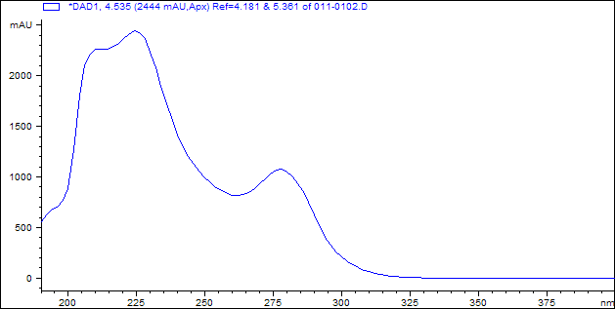

Fig. 1 UV spectrum of haloxyfop-P-methyl

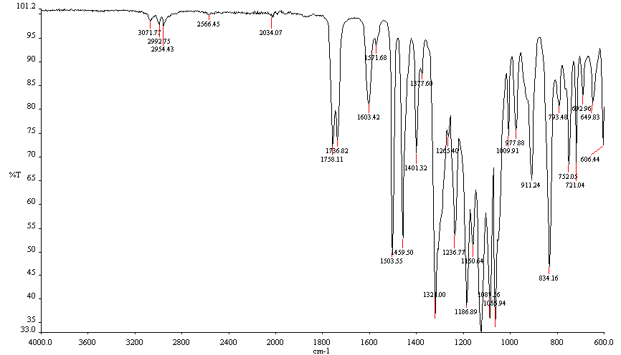

Fig. 2 IR spectrum of haloxyfop-P-methyl

